Python Project

CSP :- 211



Project Title :- General Knowledge Testing Application

INTRODUCTION

GK Tester is a Python application that has general questions related to current aﬀairs and computer. It has multiple choice questions and it also calculate scores of each correct answer. It is good for students of every age group it helps in increasing general knowledge about world, Sports and computer etc.

Before start of the quiz, the rules and regulations are displayed that includes description of the time limit, number of questions to be answered and scoring methods. Quiz is started by displaying one question with four options each based on computer and general knowledge. if the answer is correct,10 score is incremented and no negative marks for wrong answers. Question will come automatically after giving few limited question's answer quiz application will finally direct you to the score page.

OBJECTIVES

The main objective of “GK Tester” is to facilitate a user friendly environment for all users and reduces the manual eﬀort. In past days quiz is conducted manually but in further resolution of the technology we are able to generate the score and pose the queries

automatically. The functional requirements include to create users that are going to participate in the quiz, automatic score and report generation.

Working

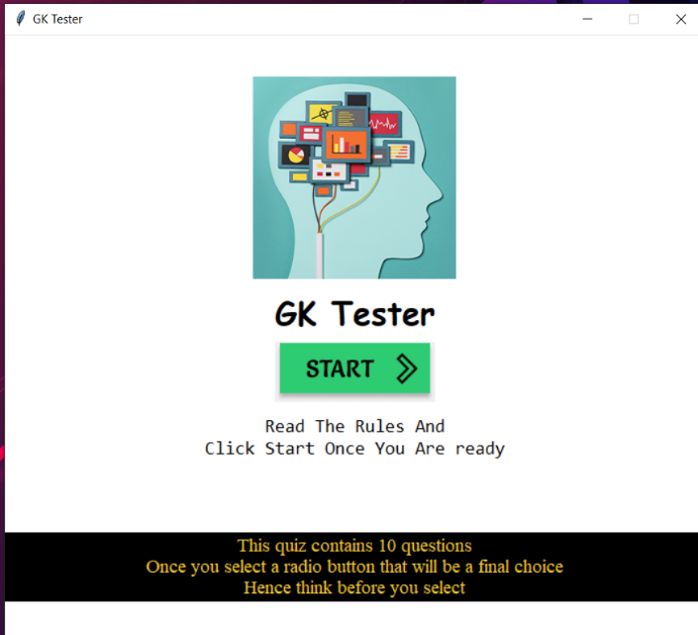 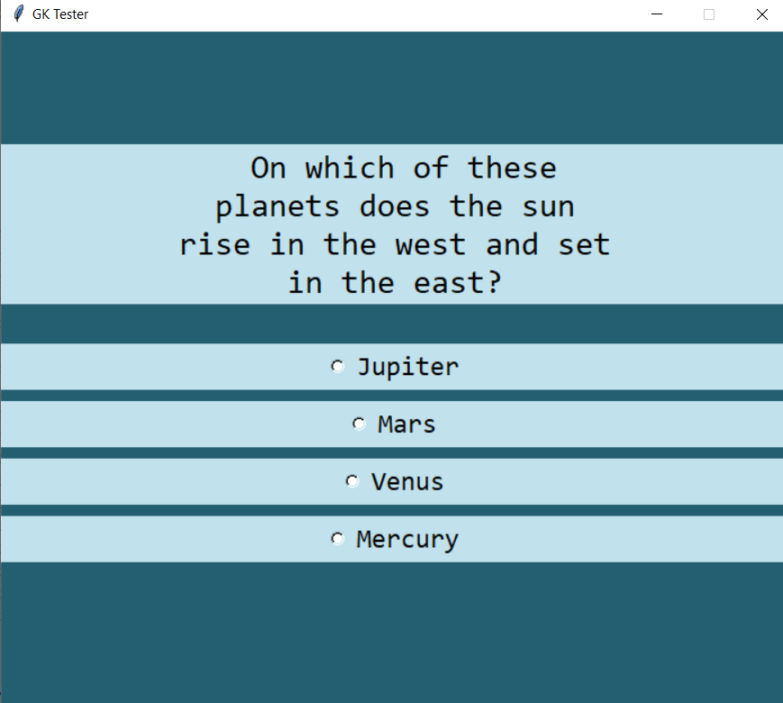

Homepage Questions

1. On Starting Application this homepage appears.
2. By clicking START button the questions starts appearing .
3. After attempting all 10 questions the Application display total score and remarks.

Library used:

The Implementation is based on tkinter and random Library

REFERENCES:

* Programming Python: Powerful Object-Oriented Programming (4th Edition)
* <https://stackoverflow.com/>
* <https://www.geeksforgeeks.org/>

Future scope and further enhancement

of the Project:

* Additional modules can be Added.
* Dataset for specific user can be generated.